SW300DC
Swing Gate Opener
User Manual

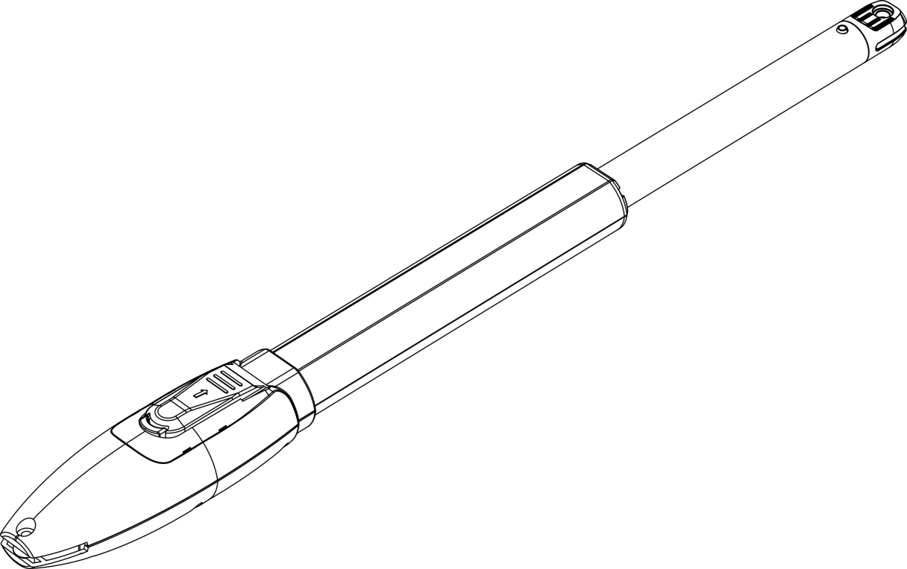

20241101

CONTENTS
Safety Instruction...............................................................................................................................1
Packing List........................................................................................................................................2
Technical Parameters........................................................................................................................3
Installation Content...........................................................................................................................4
Installation Diagram......................................................................................................................4
Size of Gate Opener.....................................................................................................................4
Tools Needed for Standard Installation...........................................................................................5
Cable List............................................................................................................................................5
Direction of Gate Opening.................................................................................................................6
Gate Opens Inwards.....................................................................................................................6
Gate Opens Outwards..................................................................................................................7
Installation Steps...............................................................................................................................8
Preparation Before Main Machine Installation...............................................................................8
Accessory Installation...................................................................................................................8
Dimension of Control Box............................................................................................................11
Wiring and Debugging.....................................................................................................................12
Wiring Instruction.......................................................................................................................12
Control Board Drawing and Instruction......................................................................................13
Photo Sensor Wiring Instruction................................................................................................14
WIFI Module Wiring Instruction.................................................................................................14
Enable and Disable Buzzer.....................................................................................................15
Battery Charging Function..........................................................................................................15
Digital Screen Setting................................................................................................................15
Travel Setting (VERY IMPORTANT)..........................................................................................16
Trimmers Setting.......................................................................................................................16
Learning Remote Control & Delete Remote Control..................................................................17
Learning Remote Control...................................................................................................17
Delete Remote Control.......................................................................................................17
Special Remote Control Key-button...................................................................................17
Control Board Settings..............................................................................................................18
Base Menu.........................................................................................................................18
Base Menu Instruction........................................................................................................19
Advanced Menu..................................................................................................................20
Advanced Menu Instruction................................................................................................22
Others..............................................................................................................................................24
Maintenance..............................................................................................................................24
Error..........................................................................................................................................24
Troubleshooting.........................................................................................................................25

Dear Users,
Thank you for choosing this product. Please read the manual carefully before assembling and using it. If you send this product to a third party, please include the manual.
1. Safety Instruction 
- Read the Manual: Please read this manual carefully before installation, as it contains important information about installation, usage, maintenance, and safety.
- Unauthorized Operations: Any operations not specified in this manual are not allowed. Incorrect use may damage the product or even cause injury or property loss.
- Installation Standards: To address potential dangers during the installation or use of the swing gate opener, installation must strictly comply with construction standards and electrical operating procedures.
- Voltage Check: Before installation, ensure that the power voltage being used matches the supply voltage of this product. Also, check that a leakage protection switch is installed and the grounding system is correct.
- Additional Equipment: Check if additional equipment or materials are required to meet specific requirements.
- Packaging Disposal: Dispose of packaging materials in compliance with local regulations.
- Do Not Modify Parts: Do not change any parts other than those specified in this manual. Any unauthorized modifications may cause malfunctions, and any damages resulting from such modifications will not be covered by the company.
- Prevent Liquid Exposure: Do not allow water or any other liquid to enter the controller or any other open devices. If this occurs, immediately disconnect the power.
- Keep Away from Heat: Keep this product away from heat and open flames, as it may damage components, cause failure, or create other hazards.
- Ensure Safe Passage: Ensure there are no vehicles, pedestrians, or objects passing through while the swing gate is moving.
- Anti-Clip Equipment: Install anti-clip equipment, such as an infrared protection switch, to prevent injury or property damage. The company is not liable for any damage or accidents arising from failure to install this equipment.
- Professional Installation Required: Installation, use, and maintenance of this product must be carried out by professionals.
- Keep Away from Children: Children are not allowed to touch the control devices or remote transmitters.
- Warning Signage: A warning sign must be placed on the swing gate according to national standards.
- Store Manual for Future Reference: Please keep this manual for future reference.

- Packing List (Standard)
No. | Picture | Name | Quantity
1 | 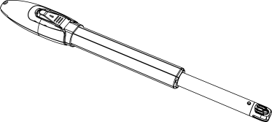 | Main machine | 2
2 | 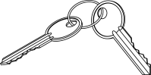 | Manual release key | 2
3 | 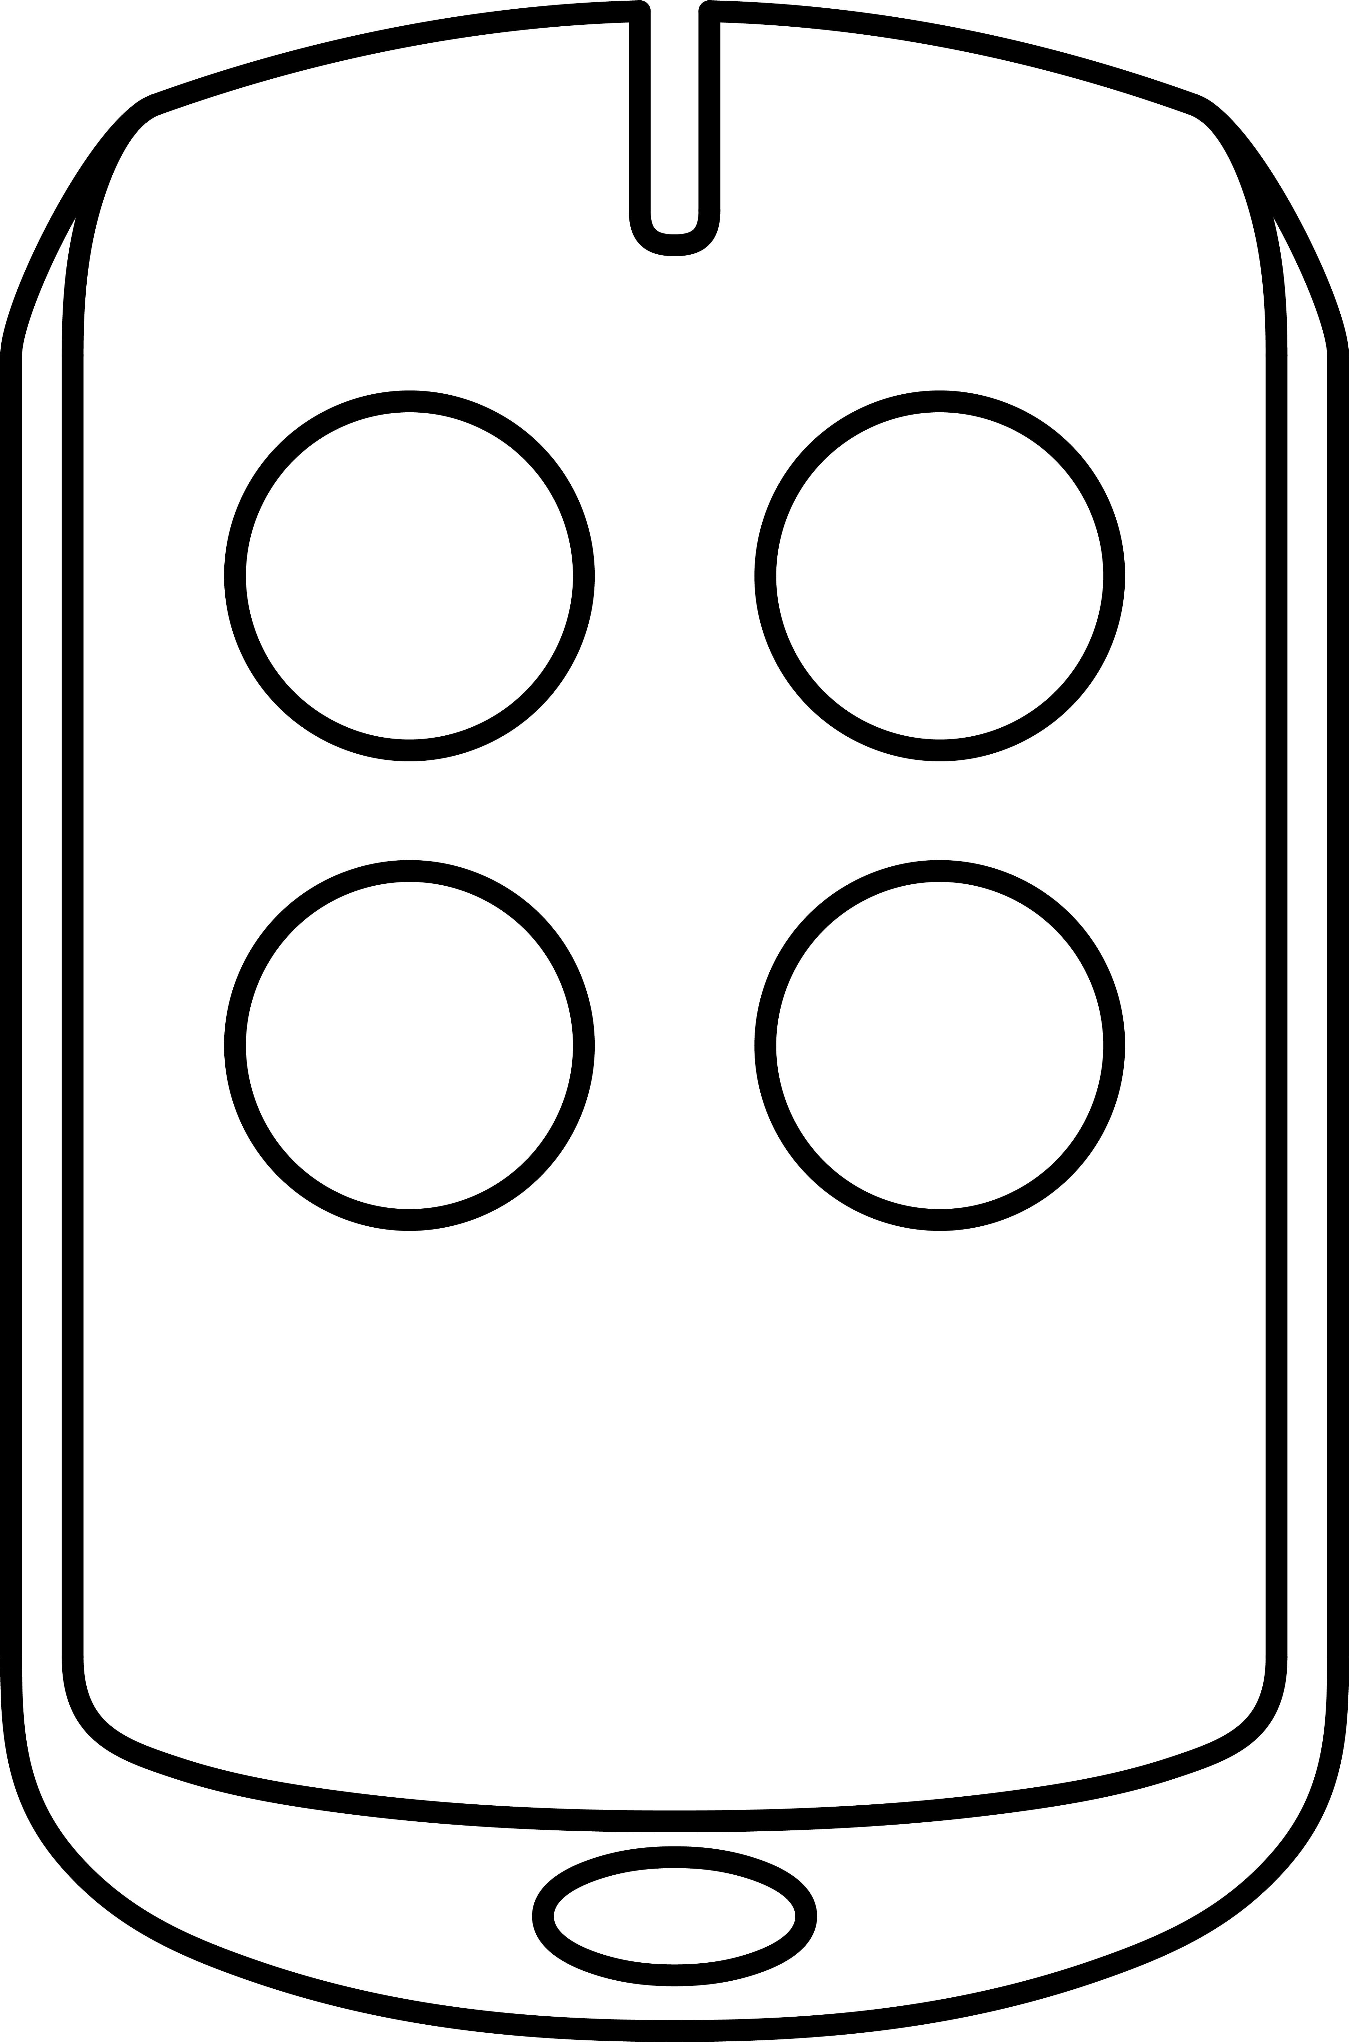 | Remote control | 2
4 | 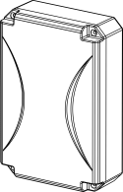 | Control box | 1
5 | 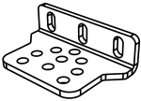 | Wall bracket | 4
6 | 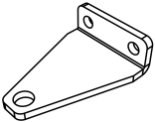 | Front mounting bracket | 2
7 | 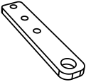 | Connecting bracket | 2
8 | 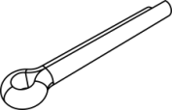 | Cotter pins | 2
9 | 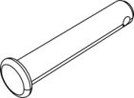 | T-shaped cylindrical pin with hole | 2
10 | 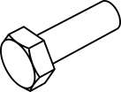 | Screw M8X25 | 4
11 | 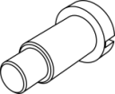 | Mounting screw (short) | 2
12 | 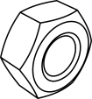 | Self-locking Nut M8 | 6
13 | 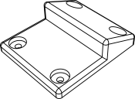 | Limit stopper | 1
Packing List (Optional)
No. | Picture | Name | Quantity
1 | 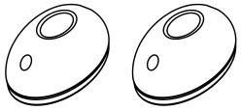 | Infrared sensor | 1
2 | 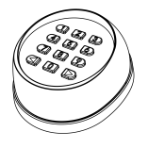 | Wireless keypad | 1
3 | 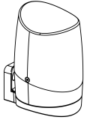 | Alarm lamp | 1
4 | 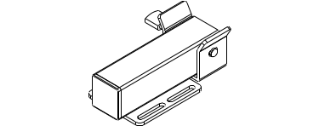 | Electric lock | 1
5 | 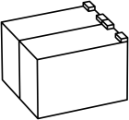 | Storage battery | 2
Due to the difference of installation environment, our company does not provide the installation accessories to fix and connect gate openers and wall. Please prepare the these installation accessories according to actual site situation.
- Technical Specifications
Model | SW300DC
Power supply | 220V/50Hz;110V/60Hz
Motor power | 50W
Gate moving speed | 18~22s/ 90°
Max.single-leaf weight | 300kg
Max.single-leaf length | 3M
Max.force | 2600N
Max.piston stroke | 32cm
Remote control distance | ≥30m
Remote control mode | Single/Four button mode
Storage battery (optional) | DC24V(4.5Ah or 9Ah)
Noise | ≤58dB
Recording of up remote controls | 32pcs
Remote frequency | 433.92 MHz
Working temperature | -20°C - +70°C
Package weight | 15kg
- Installation Content
4.1 Installation Diagram
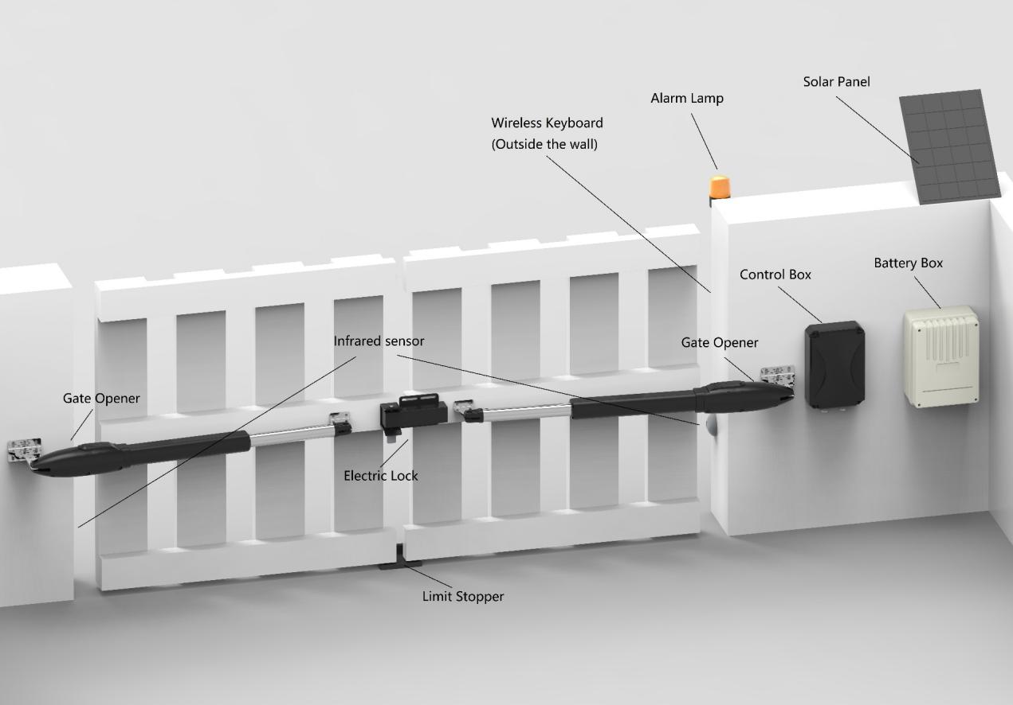
Figure 1
SW300DC swing gate opener is applicable to single leaf gate weight less than 300kg, and the length shorter than 3m. The drive mode adopts planetary transmission to combine with the screw rod transmission. This gate opener must be installed inside the enclosure or yard for protection.

4.2 Size of Gate Opener
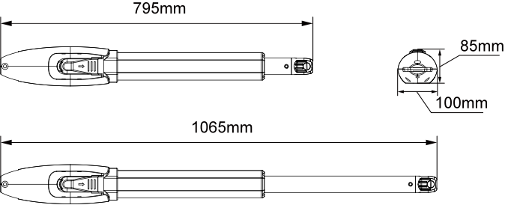
Figure 2

- Tools Needed for Standard Installation
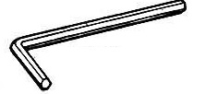 | No.6 Allen Wrench |  | Spirit Level
 | Slotted Screwdriver | 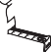 | Tape
 | Phillips Screwdriver | 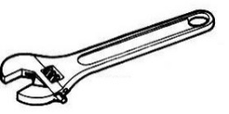 | Adjustable Wrench X 2
 | Hatching Pen

Note: the cables must be suitable for outdoor use.
- Cable List
 | Cable Application | Cable Material | Max. Length
1 | Cable of 220V control box’s power supply | 3×2.5mm² (＞30m)  3×1.5mm² (＜30m) | Unlimited
2 | Cable of gate opener’s power supply | 2×1.5mm² | 15m
3 | Cable of infrared sensor | 2×0.5mm² | 10m
4 | Cable of alarm lamp | 2×0.5mm² | 10m
5 | Cable of electric lock | 2×0.5mm² | 10m
6 | Extension cable of storage battery | 2×1.5mm² | 10m
7 | Cable of solar power | 2×1.5mm² | 10m
Due to different installation environments, installer need to prepare power cables for control box and for gate openers.
Note: cable outlet should be downward to prevent rainwater from entering wire along the cable.

- Direction of Gate Opening
7.1 Gate Opens Inwards
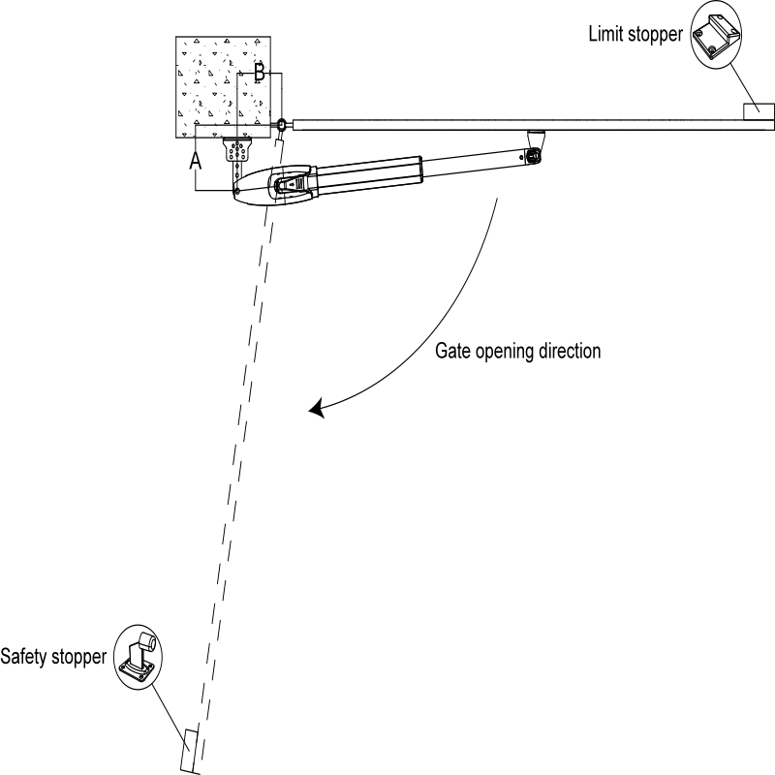
Рисунок 2
A  B | 100mm | 120 mm | 140 mm | 160 mm | 180 mm | 200 mm
100mm | 102° | 101° | 99° | 98° | 97° | 97°
120mm | 111° | 108° | 106° | 104° | 103° | 99°
140mm | 118° | 115° | 112° | 102° | 93° | 96°
160mm | 117° | 107° | 98° | 91°
180mm | 103° | 96° | 90°
200mm | 94°

7.2 Gate Opens Outwards
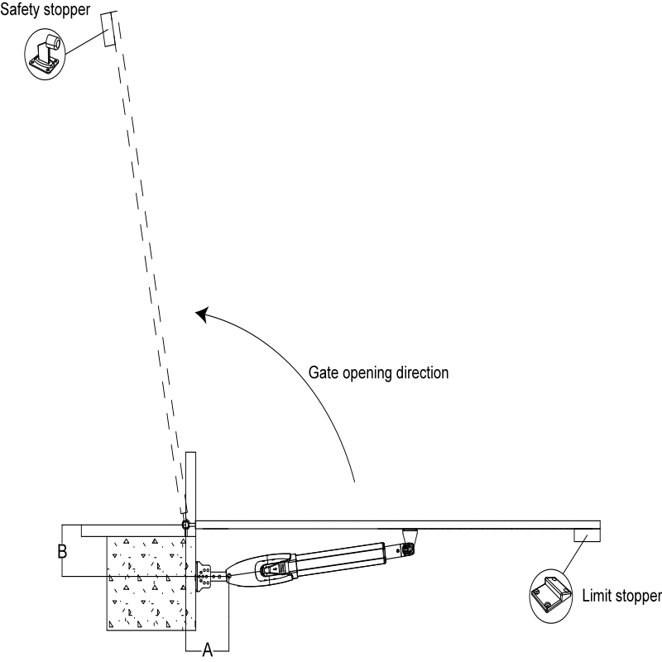
Figure 4

A  B | 100mm | 120 mm | 140 mm | 160 mm | 180 mm | 200 mm
100mm | 103° | 101° | 99° | 98° | 97° | 97°
120mm | 111° | 108° | 106° | 104° | 103° | 96°
140mm | 118° | 115° | 112° | 102° | 92°
160mm | 117° | 108° | 98° | 91°
180mm | 103° | 96° | 90°
200mm | 94°

- Installation Steps
8.1 Preparation Before Main Machine Installation
a) Before installing the gate opener, ensure that the gate is installed correctly so that it can be operated manually with ease. The gate limit stopper should effectively prevent the gate from moving further.
b) If an electric lock is to be installed, the distance between the bottom of the gate and the ground should be 40–50 mm. If the electric lock is not installed, the distance should be ≥ 20 mm.
c) The recommended mounting height for the gate opener is approximately 300 to 800 mm from the ground. Ensure that there are reliable fixed points available for mounting the brackets.

Cable
To ensure the normal operation of the gate opener and to protect the cables from damage, use PVC pipes for laying the motor, power cable, and control cables. It is recommended to use two separate PVC pipes: one for the motor and power cable and another for the control cable.

Mounting Brackets
To securely install the SW300DC gate openers, it is recommended to use expansion screws to fix the mounting brackets.

8.2 Accessory Installation
- Before installing the gate opener, mount the wall bracket on the wall. Then, fix the connecting bracket and install the front mounting bracket onto the gate.
Note: Please use a level to check alignment before securing the brackets, ensuring that the front mounting bracket and the connecting bracket are on the same level.

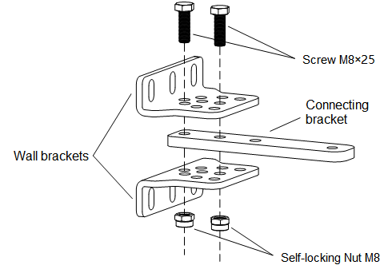
Figure 5
B) The connecting bracket and the wall bracket can be connected according to different conditions, please refer to figure 6.
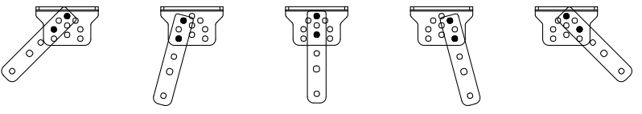Figure 6

C) Before the installation, please unlock the two main machines. Unlock method: Open the manual release cover, insert the manual release key, rotate the key until it’s released, as shown in Figure 7, then turn the telescopic arm, you’ll find it’s stretched by hand easily.
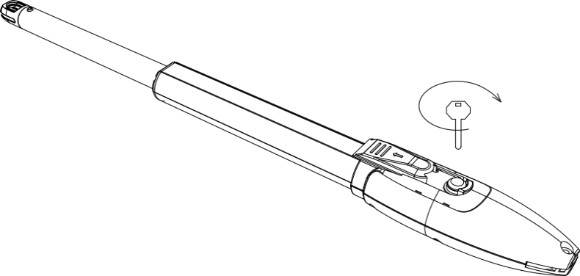

Figure 7
- Connect the main machine with connecting brackets by screw and nut as shown in Figure 8.
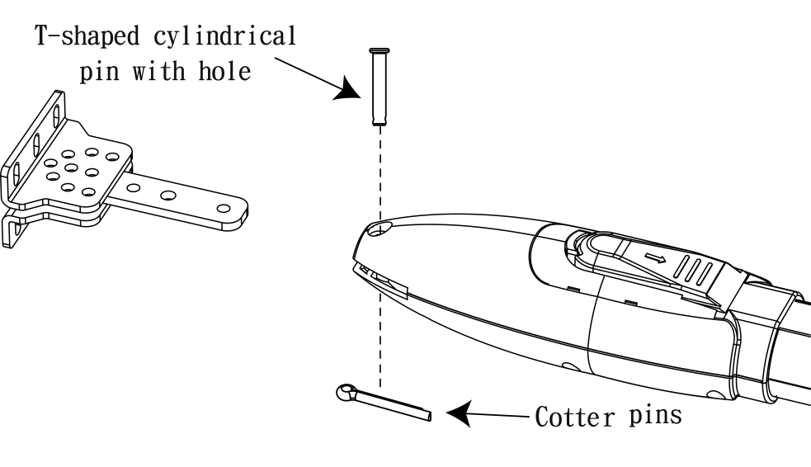
Figure 8
- As shown in figure 8 below, connect wall bracket with wall according to marked position. Then, connect main machine with wall bracket by screw and nut. (Please use spirit level to make sure the installation levelness.)
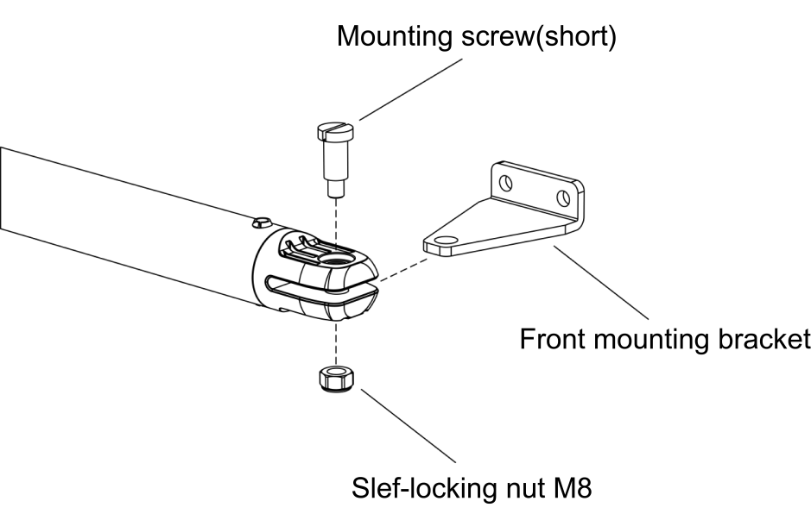
Figure 9
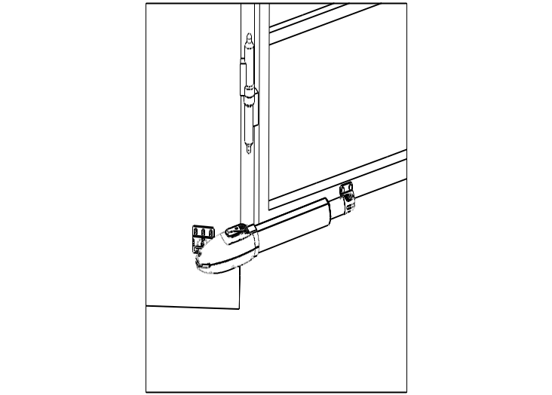
Figure 10
8.3 Dimension of Control Box
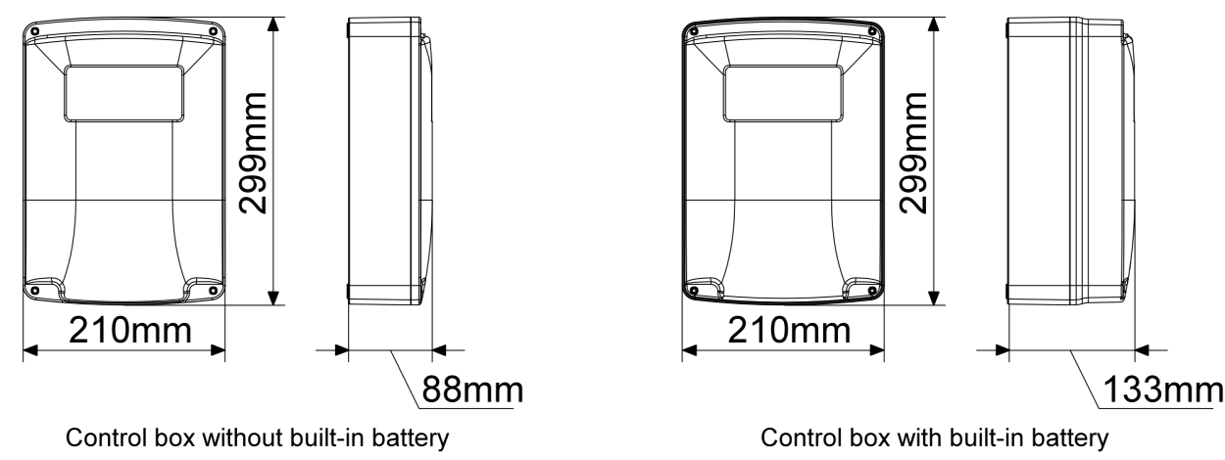
Figure 11
Warning 
- To ensure safety, when the gate opens outward, an OPEN limit stopper must be installed at the OPEN limit position to prevent the gate opening angle from exceeding the travel range of the gate opener, which could cause damage; A CLOSE limit stopper must be installed at the CLOSE limit position to ensure accurate stopping alignment for both gates (as shown in Figures 4). When the gate opens inward, a CLOSE limit stopper must be installed at the CLOSE limit position (as shown in Figures 3).
- Before installing the gate opener, make sure that the gate opener and its components are in good mechanical condition and that the gate can be easily operated manually.
- One control box can control either one or two gate openers.
- An earth leakage circuit breaker must be installed in a location where the gate movement is visible, and the control box should be mounted at a height of over 1.5 meters to prevent access by children.
- After installation, please check that the mechanical performance is in good condition, the gate operates smoothly after manual unlocking, and the infrared sensor (optional) is correctly installed and functional.

9. Wiring and Debugging
9.1 Wiring Instruction

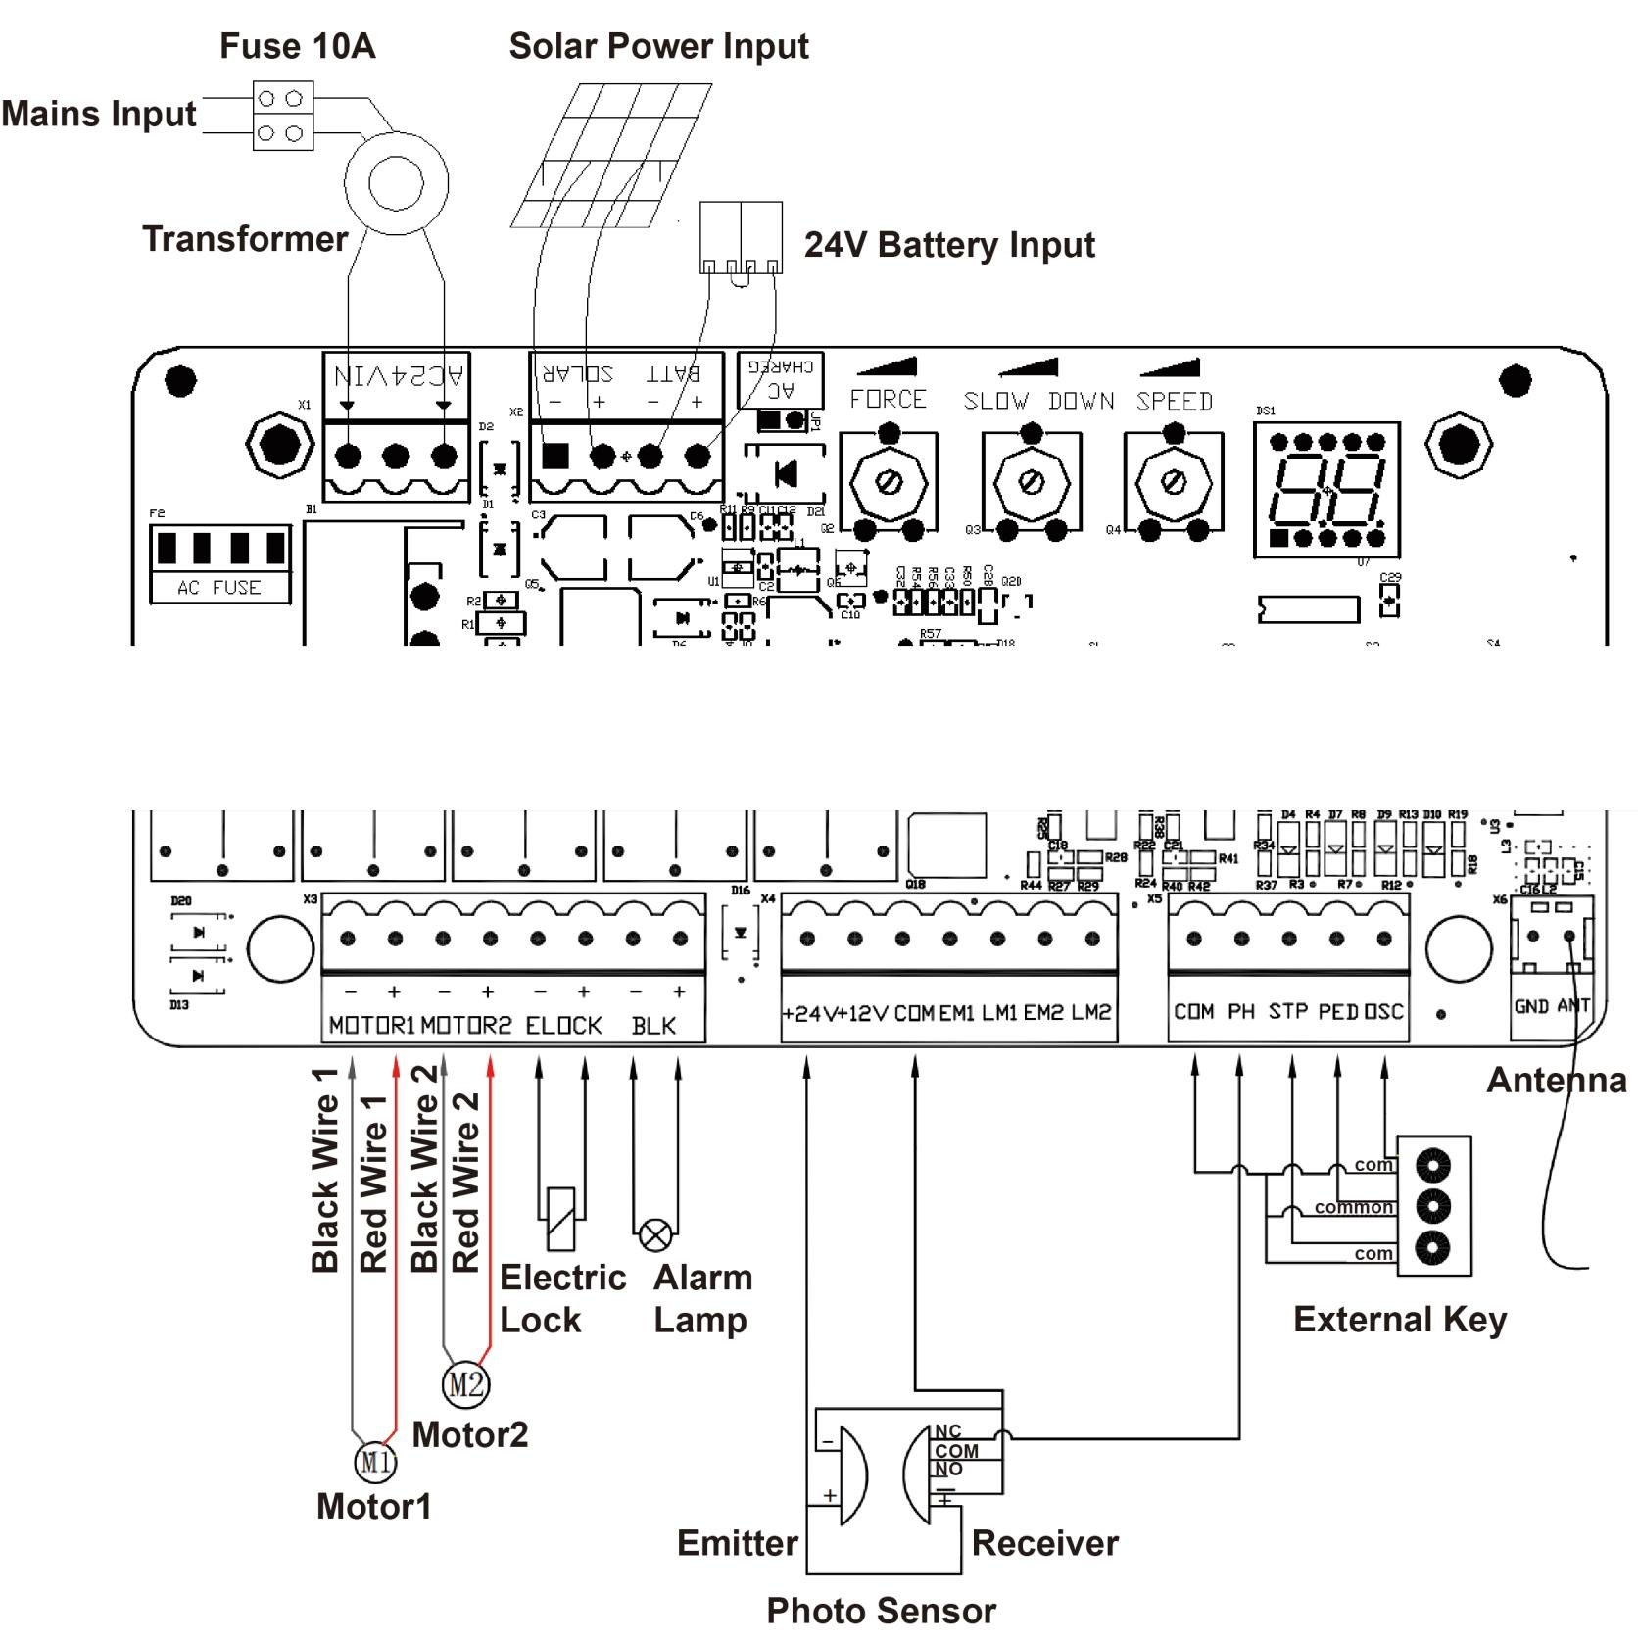

Figure 12

9.2 Control Board Drawing and Instruction
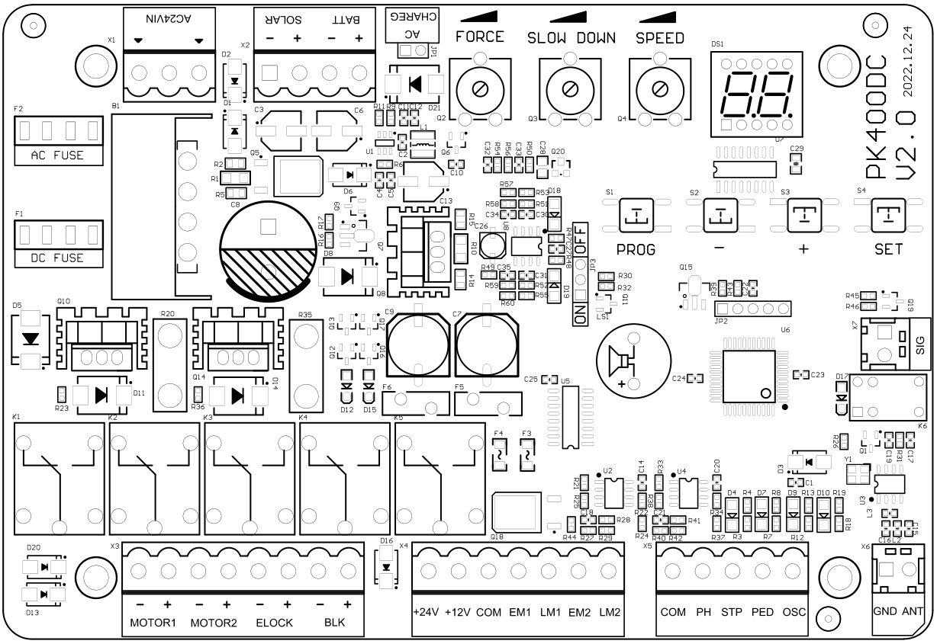
Figure 13

Terminal | Description
- AC24VIN | 24VAC Power Supply Input
- +SOLAR- | Solar Power Input
- +BATT- | 24V Battery Input
- FORCE | Obstacle Sensitivity
- SLOW DOWN | Slow Stop Distance
- SPEED | Gate Moving Speed
- MOTOR1 | Motor1 Output
- MOTOR2 | Motor2 Output
- -ELOCK+ | Electric Lock Output
- -BLK+ | Alarm Lamp Output (Note: pay attention to polarity)
- +24V | 24V Output Positive
- +12V | 12V Output Positive (No output in standby mode)
- EM1 | Motor1 Hall Sensor Power Output
- LM1 | Motor1 Hall Sensor Limit Signal Input
- EM2 | Motor2 Hall Sensor Power Output
- LM2 | Motor2 Hall Sensor Limit Signal Input
- PH | Photo Sensor Input Active
- PED | Single Gate/Pedestrian Mode Input Active
- OSC | Single Channel Input Active
- ANT | Antenna
- COM | Common
- SIG | The signal is normally closed only when the gate is fully closed
Photo Sensor Wiring Instruction

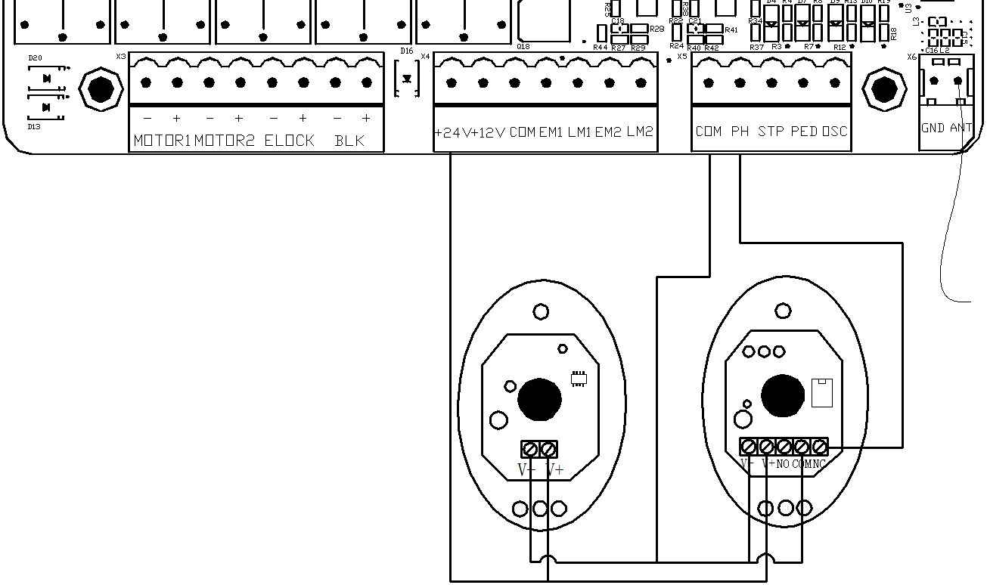

Figure 14

WIFI Module Wiring Instruction

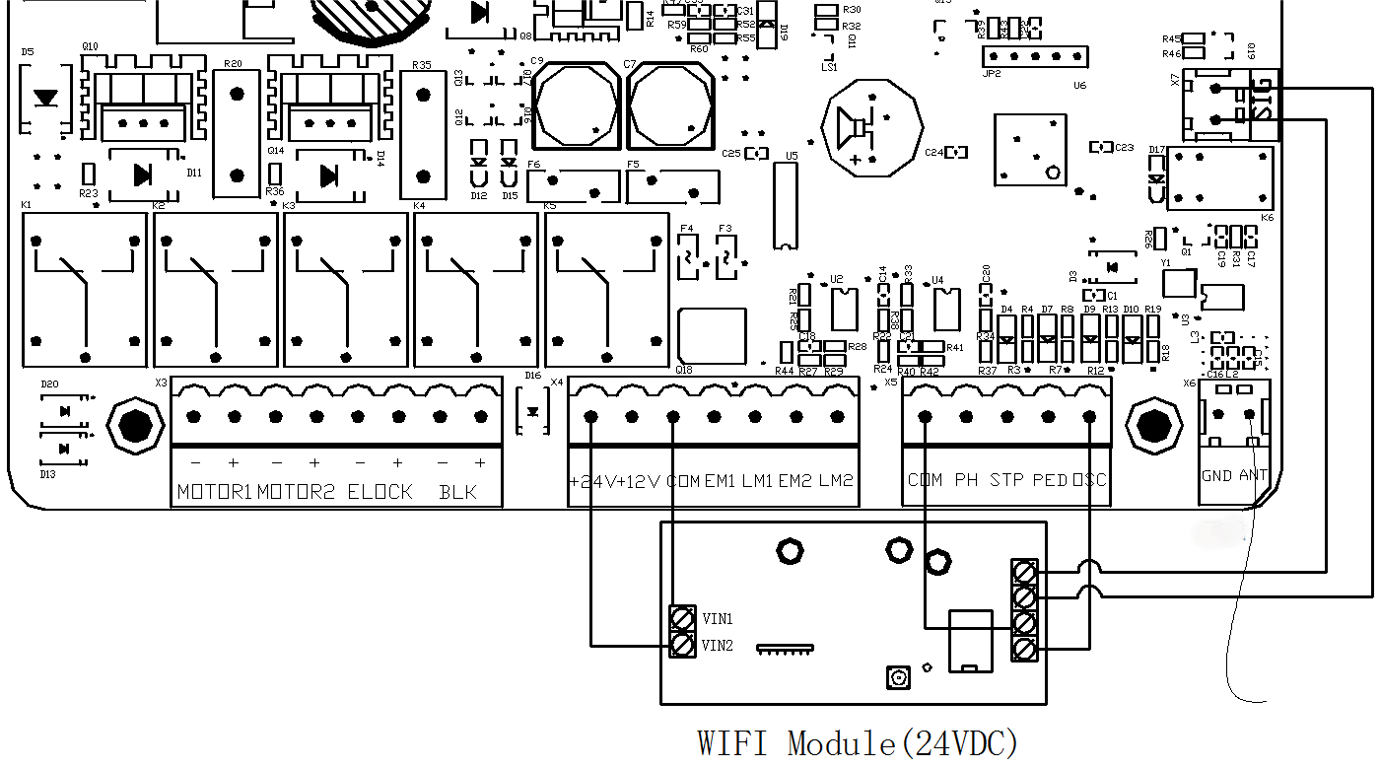
Figure 15
Enable and Disable Buzzer

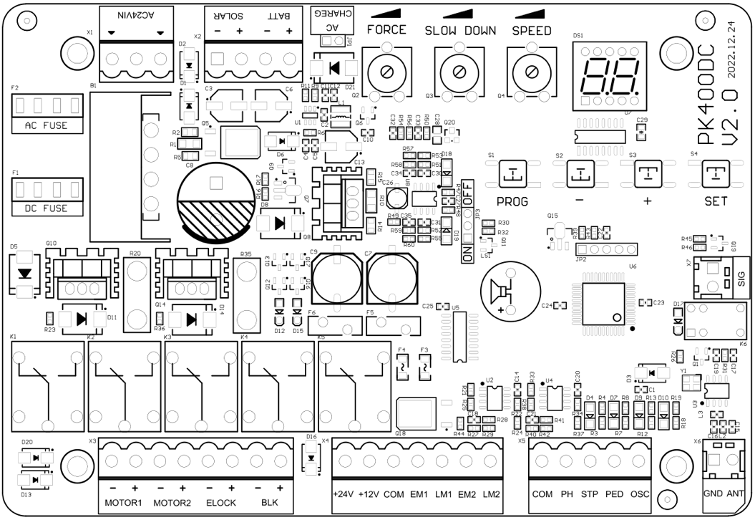
Jumper to ON: Enable the buzzer | Jumper to OFF: Disable the buzzer
Zoom in the buzzer jumper

Figure 16

Battery Charging Function
Insert the jumper to enable battery charging function
Remove the jumper to disable battery charging function
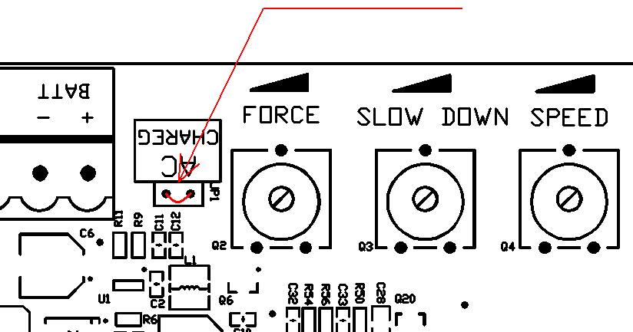

Figure 17
Note: When using solar power only, it is recommended to remove the jumper to reduce power consumption.

9.3 Digital Screen Setting
When the control board is working, users can check the working status of gate opener by the digital screen on the control board.
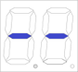 no input
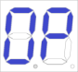 under opening state
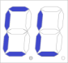 under closing state
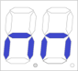 manual mode
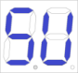 travel setting

9.4 Travel Setting (VERY IMPORTANT)
During the initial installation of gate openers, it is necessary to set the travel limits for both the open and closed positions.

Open both sides of the gate and lock the clutch. Then press and hold the "+" button on the control board until the digital screen shows "SU". At this point, the gate will first move towards the closing direction until it reaches the closed position and blocks, and then the gate will automatically open. When the two swing gates are fully open, the gates will automatically close for the second time, and the travel setting will be completed when the gates are closed. If the slow speed distance of gate is not appropriate, adjust the "SLOW DOWN " trimmer to revise the distance.

Notes
- Wiring: connect the black wire of gate opener 1 to the left side of MOTOR1 and the brown wire to the right side. For gate opener 2, connect the black wire to the left side of MOTOR2 and the brown wire to the right side.
- Single gate mode: connect the gate opener to MOTOR1.
- Sudden Stops: If the gate stops unexpectedly during travel setting, please increase the resistance force by the Obstacle Sensibility Trimmer.
- Obstacle Handling: If the gate fails to stop when encountering an obstacle during travel setting, please appropriately decrease the resistance force by the Obstacle Sensitivity Trimmer.
- Speed Adjustments: After adjusting the "SPEED" trimmer, the installer must redo the travel setting.
- Cancel Setting: During the travel setting, you can long press the “SET” button to cancel the setting.

9.5 Trimmers Setting
Obstacle Sensitivity Trimmer
To adjust the sensitivity to obstacles: turn clockwise to increase sensitivity and counterclockwise to decrease it. If there are environmental influences such as strong winds, adjust the trimmer as needed to match environmental conditions.
Slow Speed Distance Trimmer
To adjust the distance for slow speed: turn clockwise to increase and counterclockwise to decrease the slow speed distance. Avoid setting a very short slow speed distance to prevent gate collisions.
Gate Moving Speed Trimmer
To adjust the gate moving speed: turn clockwise to increase speed and counterclockwise to reduce speed. This setting affects the opening and closing travel time. Complete this adjustment before performing the travel setting.
Note: after adjusting the SPEED trimmer, please perform the travel setting again.

Counterclockwise  to decrease | Clockwise  to increase | Counterclockwise  to decrease | Clockwise  to increase | Counterclockwise  to decrease | Clockwise  to increase
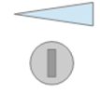
FORCE  Obstacle Sensitivity Trimmer |  | SLOW DOWN  Slow Speed Distance Trimmer |  | SPEED  Gate Moving Speed Trimmer

Figure 18

9.6 Learning and Deleting Remote Control
9.6.1 Learning Remote Control
Press and hold "-" button, the alarm lamp will keep flashing, and the digital screen will show the remote control mode:
- "PO" — dual swing gate single-channel mode
- "Pd" — single gate four-channel mode
Press the button on the remote control to be learned, the digital screen will show the number of current learned remote control, then the remote control learning is completed. (The default of new paired remote control is dual swing gate single-channel mode).

9.6.2 Deleting Remote Control
Enter into “AE” on the digital screen and select “rE” to delete all paired remote controls.

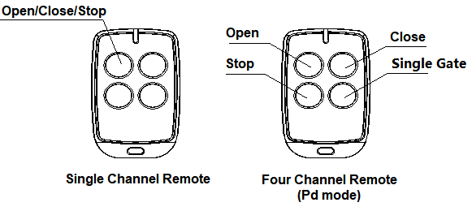
Figure 19

9.6.3 Special Remote Control Key Combination
Press and hold the following combination keys for 5 seconds.
- C (stop) + D (single gate) – Enters remote control learning mode.
9.7 Control Board Settings
9.7.1 Base Menu
Press the "PROG" to enter the base menu.
The Digital screen will display “NE”, select other functions within this menu by “+” and “-” buttons.
Press "SET" to confirm or to enter a sub-menu.
Press “PROG” to exit the menu.
If there is no input for one minute, the menu will automatically exit.

 |  | Base Menu |  | Sub-Menu
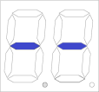 |  | 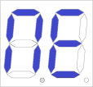 | Working  Mode | 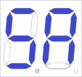 | Standard mode (default)
Initial  screen |  |  | Working  Mode | 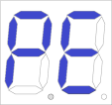 | Automatic closing mode
 |  |  | Working  Mode | 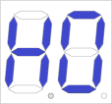 | Community mode
 |  |  | Working  Mode | 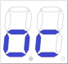 | External three buttons
 |  |  | Working  Mode | 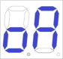 | External three buttons  (with the function of automatic closing)
 |  | 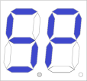 | Dual gate /single gate mode | 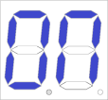 | Dual gate mode (default)
 |  |  | Dual gate /single gate mode | 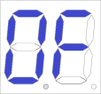 | Single gate mode
 |  | 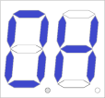 | Gate opening time interval | 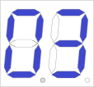 | 3 seconds (default)
 |  | 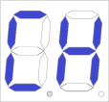 | Automatic closing time | 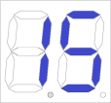 | 15 seconds (default)
 |  | 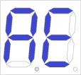 | Remote control mode | 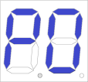 | Single-channel mode (default)
 |  |  | Remote control mode | 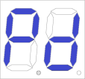 | Four-channel mode
 |  |  | Remote control mode | 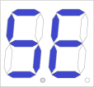 | Pedestrian mode
 |  |  | Remote control mode | 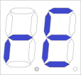 | Delete remote control
 |  | 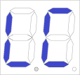 | Low consumption  mode |  | Low consumption mode ON  (default)
 |  |  | Low consumption  mode |  | Low consumption mode OFF
9.7.2 Base Menu Instruction
Menu  Press "PROG" to enter the base menu | Option  Press “+” (up) or “-” (down) to select;  Press “SET” to confirm | Default  /Attention
Working Mode | Standard mode; OSC/PED/STP represents dual gate single channel mode/pedestrian mode/stop  OSC -- dual gate single channel mode  PED -- pedestrian mode  STP -- stop  PS.: Pedestrian mode means that under dual gate mode, when both gates all closed, only M1 will open.  OSC/PED/STP standard mode with automatic closing function. When the gate opens, it will automatically close after the automatic closing time. If a “close the gate” command is sent during the automatic closing waiting period, the automatic closing function will be canceled.  Community mode (with automatic closing function). When the gate opens, no gate commands will be responded to until it closes automatically. If a gate command is sent during the closing process, the gate will reopen. If a gate command is sent during the automatic closing waiting period, the waiting time will be recalculated. If the gate does not close completely for more than ten consecutive attempts, the automatic closing function will be canceled, and the gate will close after resending the gate closing command. Note that in community mode, the gate still retains the automatic closing function in case of encountering obstacles.  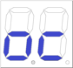 External three buttons (OSC/PED/STP represents open/pedestrian/stop)  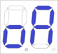 External three buttons: OSC/PED/STP is external three-button mode (with the function of automatic closing) | Standard mode; OSC/PED/STP represents dual gate single channel mode/pedestrian mode/stop
Dual Gate/Single Gate Mode | Dual gate mode (default).  Single gate mode. | Dual gate mode.
Gate Opening Time Interval | The gate opening time interval is 0-10 seconds (default is 3 seconds). If the interval is less than 2 seconds, the electric lock cannot be used. | 3 seconds.
Automatic Closing Time | Automatic closing time can be set as 15 (default), 30, 60, 90 seconds. | 15 seconds.
Remote Control Mode | Single channel mode.  Four channel mode (open/close/stop/pedestrian mode)  Pedestrian mode.  Delete all paired remote controls. | Single channel mode.
Low Consumption Mode | Low consumption mode ON  (When there is no operation on the initial screen, the control board will automatically enter the low consumption mode after 1 minute.)  Low consumption mode OFF | Low consumption mode ON

9.7.3 Advanced Menu
Press and hold "PROG" for 2 seconds to enter the advanced menu.
The digital Screen will display “TL”. select other functions within this menu by “+” and “-” buttons.
Short press “SET” to confirm or to enter a sub-menu.
Short press “PROG” to exit the menu.
If there is no input for one minute, the menu will automatically exit.

 |  | Advanced Menu |  | Sub-Menu
 |  | 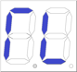 | Travel time adjustment | 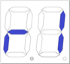 | Time of gate 1
Initial  screen |  |  | Travel time adjustment | 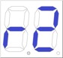 | Time of gate 2
 |  |  | Travel time adjustment | 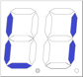 | Time fine tuning of gate 1
 |  |  | Travel time adjustment | 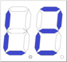 | Time fine tuning of gate 2
 |  |  |  | 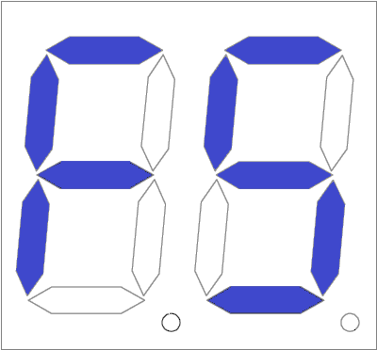 | Force of obstacle sensitivity in fast speed
 |  |  |  | 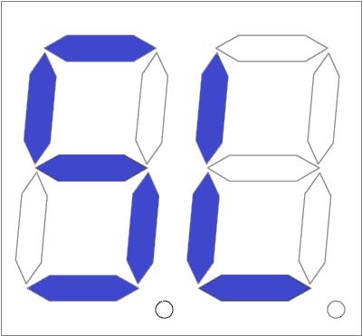 | Force of obstacle sensitivity in slow speed
 |  |  |  | 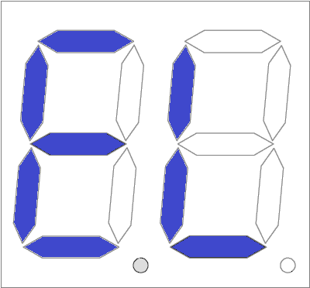 | Electric lock unlocked duration
 |  |  |  | 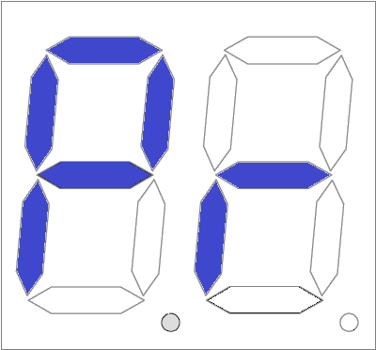 | Time of motor continuously running after travel
 |  | 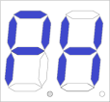 | Photo sensor | 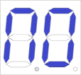 | Photo sensor normally ON
 |  |  | Photo sensor | 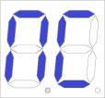 | Photo sensor normally OFF
 |  | 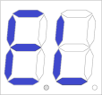 | Electric lock |  | Electric lock normally ON
 |  |  | Electric lock |  | Electric lock normally OFF
 |  | 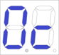 | Reverse push lock |  | Reverse push lock mode OFF
 |  |  | Reverse push lock | 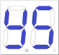 | Reverse push lock mode ON
 |  | 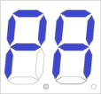 | Alarm lamp |  | Alarm lamp normally ON
 |  |  | Alarm lamp | 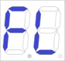 | Alarm lamp normally Flash
 |  | 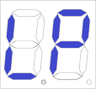 | Limit switch | 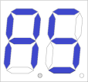 | Limit stopper (Default)
 |  |  | Limit switch | 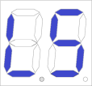 | Hall sensor
 |  | 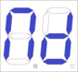 | Gate opener selection | 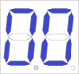 | SW400DC
 |  |  | Gate opener selection | 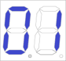 | SW300DC (default)
 |  |  | Gate opener selection | 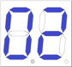 | SW200DC
 |  |  | Gate opener selection | 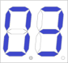 | PK300DC
 |  |  |  | 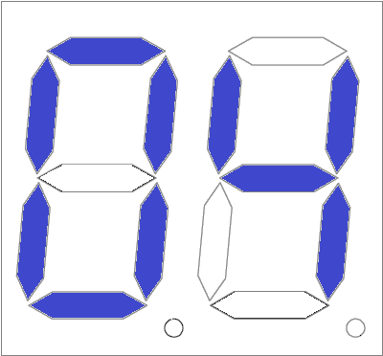 | PK400DCGL
 |  | 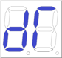 | Gate opening direction | 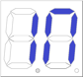 | Gate Opens Inwards
 |  |  | Gate opening direction | 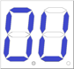 | Gate Opens Outwards
 |  | 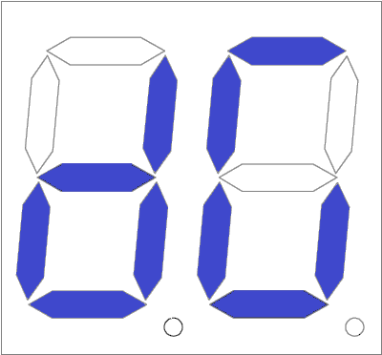 | Reverse push gate |  | Disable the Reverse push gate function
 |  |  | Reverse push gate | 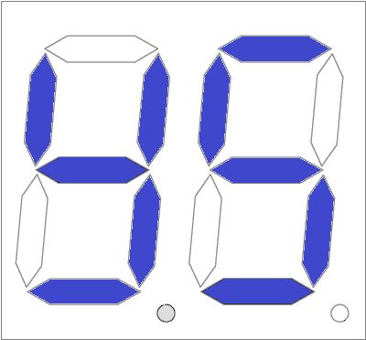 | Enable the Reverse push gate function
 |  | 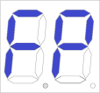 | Factory default setting |  | Default setting cancellation
 |  |  | Factory default setting |  | Factory default setting
9.7.4 Advanced Menu Instruction
Menu  Long press "PROG" 2 seconds to enter into base menu. | Option  Press “+” (up) or “－” (down) to select;  Press “SET” to confirm. | Default/Attention
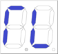  Travel Time Adjustment | 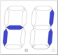 Time of of gate1  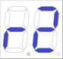 Time of of gate2  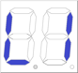 Time fine tuning of of gate 1  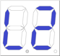 Time fine tuning of of gate 2  Obstacle sensitivity force in fast speed (When the gate is moving at full speed, the obstacle sensitivity force is at its lowest. If the obstacle sensitivity trimmer turns to maximum and an error appears on the screen, increase the value; If the trimmer turns to minimum and the obstacle sensitivity force is still too high, decrease the value)  Obstacle sensitivity force in slow speed (When the gate is moving at slow speed/soft start and stop, the obstacle sensitivity force is at its lowest. If the obstacle sensitivity trimmer turns to minimum and the gate reaches the limit stopper but the motor still runs, decrease the value. If the obstacle sensitivity force is maximum but the gate stops before reaching the limit stopper, increase the value.)  Electric lock opening time (The duration of electric lock stays opening, default is 3 seconds)  Time of motor continuously running after travel (5S-60S) | After automatic learning, if the travel is not ideal, it can be adjusted manually. Under the limit stopper mode, the shorter the time, the greater the slow speed distance of the gate. Under the Hall sensor mode, the shorter the time, the shorter the gate travel.  Any adjustments to the obstacle sensitivity force for fast and slow speeds must be performed only by a licensed electrician.
Photo Sensor | N/O; photo sensor normally ON. (Default)  N/C; photo sensor normally OFF. | N/O; photo sensor normally ON.
Electric Lock | Electric lock normally ON. (Default)  Electric lock normally OFF. | Electric lock normally ON.
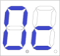  Reverse Push Lock | Reverse push lock mode OFF  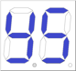 Reverse push lock mode ON  (When the electric lock is activated, the gate opener M1 will move slightly in the closing direction to prevent the electric lock from jamming and becoming unable to open.) | Reverse push lock mode OFF
Alarm Lamp | Alarm lamp is normally on. 24V power supply. (Default)  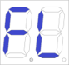Alarm lamp normally flashes. 24V power supply. | Alarm lamp is normally ON. 24V power supply.
Limit Mode | Limit stopper (Default)  Hall sensor | Limit stopper  (Default)
Gate Opener Selection | SW400DC  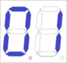 SW300DC  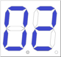 SW200DC  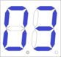 PK300DC  PK400DCGL | SW300DC
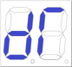  Gate Opening Direction | 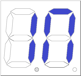 Gate Opens Inwards (Default)  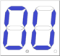 Gate Opens Outwards | Gate Opens Inwards
Reverse Push Gate | Disable the Reverse Push Gate function  Enable the Reverse Push Gate function  (When enabled, the gate will move slightly backward after reaching the position to prevent it from getting stuck.) | Disable the Reverse Push Gate function
Factory Default Setting | Cancel factory default setting.  Factory default setting completed.

10. Others
10.1 Maintenance
Monthly inspect the gate to ensure it is operating normally.
For safety purposes, it is recommended that each gate be equipped with an infrared sensor, which should also be inspected regularly.
Before installation and operation of the gate opener, please read all instructions carefully.
We reserve the right to modify the user manual without prior notice.

10.2 Errors
Errors that may occur when the gate is operating properly.
Error Indication | Error Cause | Solution
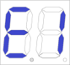 | Gate 1 obstructed in opening | 1. Check if there is any obstruction when gate 1 opens  2. Adjust obstacle sensitivity appropriately  3. Increase slow speed distance appropriately
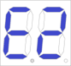 | Gate 2 obstructed in opening | 1. Check if there is any obstruction when gate 2 opens.  2. Adjust obstacle sensitivity appropriately  3. Increase slow speed distance appropriately
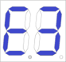 | Gate 1 obstructed in closing | 1. Check if there is any obstruction when gate 1 closes  2. Adjust obstacle sensitivity appropriately  3. Increase slow speed distance appropriately
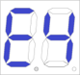 | Gate 2 obstructed in closing | 1. Check if there is any obstruction when gate 2 closes  2. Adjust obstacle sensitivity appropriately  3. Increase slow speed distance appropriately
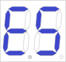 | Photo sensor disconnect | 1. Check the photo sensor setting status  2. Check if there is any obstruction in the infrared area
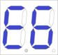 | Gate 1 closes before gate 2 | 1. Relearn travel setting  2. Adjust the opening time interval
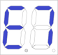 | Motor runs too long | 1. Check if the travel setting is completed  2. Check if Hall sensor is damaged  3. If the gate doesn’t stop when in slow speed state, counterclockwise the trimmer to decrease the obstacle sensitivity or reduce the SL value in travel time adjustment in advanced menu
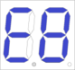 | Travel setting not completed | Re-learn the travel setting

10.3 Troubleshooting
Problems | Possible Reasons | Solutions
The gate cannot open or close normally, and the display does not light. | 1. Power is off.  2. Fuse is burned.  3. Control board power wiring issue. | 1. Turn on the power switch.  2. Check the fuse and replace it if burned.  3. Rewire according to the manual.
The gate can open but cannot close. | 1. Photo sensor wiring issue.  2. Photo sensor mounting issue.  3. Photo sensor is blocked by obstacle.  4. Obstacle sensitivity is too high. | 1. If the photo sensor is not connected, ensure that 5 and 6, 5 and 7 are short-circuited; if using photo sensor, ensure correct wiring and the photo sensor mode is N.C.  2. Ensure the photo sensor mounting positions are aligned.  3. Remove the obstacle.  4. Reduce the obstacle sensitivity.
Remote control doesn't work. | 1. Low battery in the remote control.  2. Remote control not learned. | 1. Replace the remote control battery.  2. Re-learn the remote control.
Press OPEN or CLOSE but the gate does not move, motor makes noise. | Gate movement is not smooth. | Adjust the motor or gate according to the actual situation.
Circuit breaker tripped. | Short circuit in the power supply line or motor line. | Check the wiring.
Remote control range is too short. | Signal is blocked. | Attach an external receiver antenna, 1.5 meters above the ground.
The gate stops or reverses at the middle position. | 1. Motor output force is insufficient.  2. Obstacle sensitivity is too high.  3. Gate encounters an obstacle. | 1. Check if the transformer power is normal; if not, replace the transformer.  2. Adjust the FORCE setting.  3. Remove the obstacle.

PK400DC-A1(SW300DC)

